Widmer, Michelle
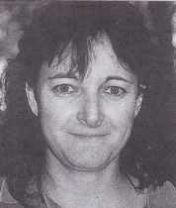
Graduated from Dwellingup cadet school in 1986. Appointed as forest guard at Metropolitan region in 1987. CALMfire plantations fire coordinator at Bunbury in 1999.

